|  |  |
| --- | --- |
|  | **AIR UNIVERSITY** |
| **DEPARTMENT OF COMPUTER SCIENCE** |
| **Lab Task 1** |

**Student Name: Hamza Umer Farooq Reg. No: 200789**

**Subject: Compiler Construction Semester: VIII**

**Objective: Lab Task 1**

**ASSESSMENT:**

|  |  |  |  |  |  |
| --- | --- | --- | --- | --- | --- |
| **Attributes** | **Excellent**  **(5)** | **Good**  **(4)** | **Average**  **(3)** | **Satisfactory**  **(2)** | **Unsatisfactory (1)** |
| **Ability to Conduct**  Task |  |  |  |  |  |
| **Ability to assimilate the results** |  |  |  |  |  |
| **Effective use of theorems/postulates/formulas** |  |  |  |  |  |

Total Marks:

Obtained Marks:

**REPORT ASSESSMENT:**

|  |  |  |  |  |  |
| --- | --- | --- | --- | --- | --- |
| **Attributes** | **Excellent**  **(5)** | **Good**  **(4)** | **Average**  **(3)** | **Satisfactory**  **(2)** | **Unsatisfactory**  **(1)** |
| **Data presentation** |  |  |  |  |  |
| **Experimental results** |  |  |  |  |  |
| **Conclusion** |  |  |  |  |  |

**Question 1**

**Output For a specific input**

%{

#include <stdio.h>

%}

%%

"hello world" printf("goodbye\n");

\n {return 0;}

%%

int yywrap(){

return 1;

}

int main(){

yylex();

return 0;

}

**Output**

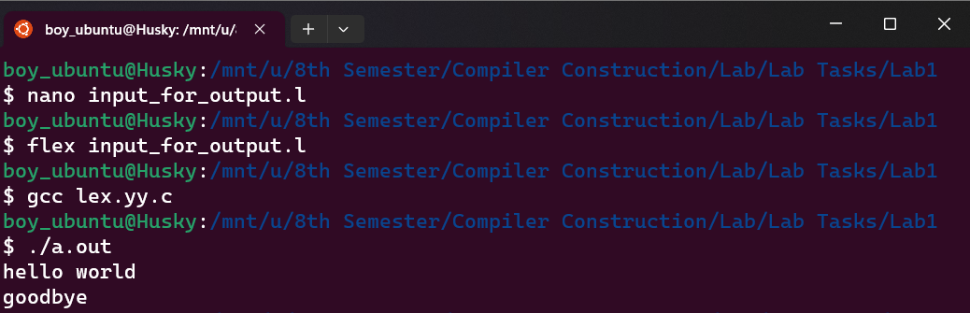

**Question 2**

**Count Total Spaces**

%{

#include <stdio.h>

int count = 0;

%}

%%

" " {count++;}

\n {printf("\nspaces = %d\n",count);

count = 0;}

%%

int yywrap(){

return 1;

}

int main(){

yylex();

return 0;

}

**Output  
  
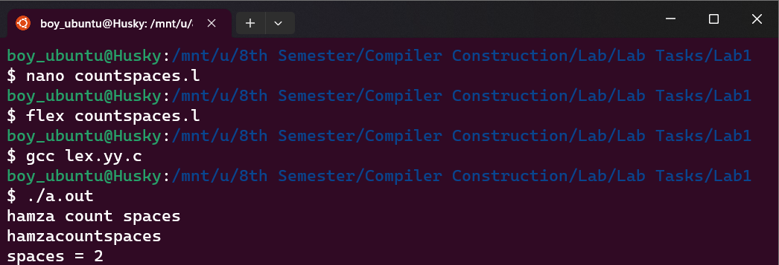**

**Question 3**

**Count total words**

%{

#include <stdio.h>

int count = 0;

%}

%%

[A-Za-z]" " {count++;}

[A-Za-z]\n {count++;

printf("\ncount = %d\n",count);

count=0;}

\n {printf("\ncount = %d\n",count);

count=0;}

%%

int yywrap(){

return 1;

}

int main(){

yylex();

return 0;

}

**Output  
  
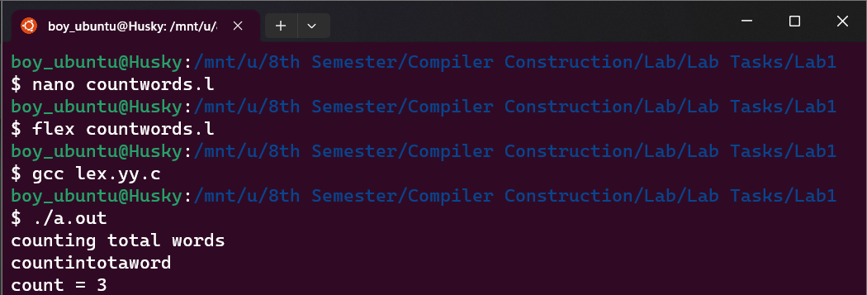**

**Question 4**

Count vowels and consonants:  
  
%{

#include <stdio.h>

int count_vowels = 0;

int count_cons = 0;

%}

%%

[AaEeIiOoUu] {count_vowels++;}

[^AaEeIiOoUu\n] {count_cons++;}

\n {

printf("\nTotal Vowels = %d\n",count_vowels);

printf("\nTotal Consonants = %d\n",count_cons);

count_vowels=0;

count_cons=0;

}

%%

int yywrap(){

return 1;

}

int main(){

yylex();

return 0;

}

**Output**

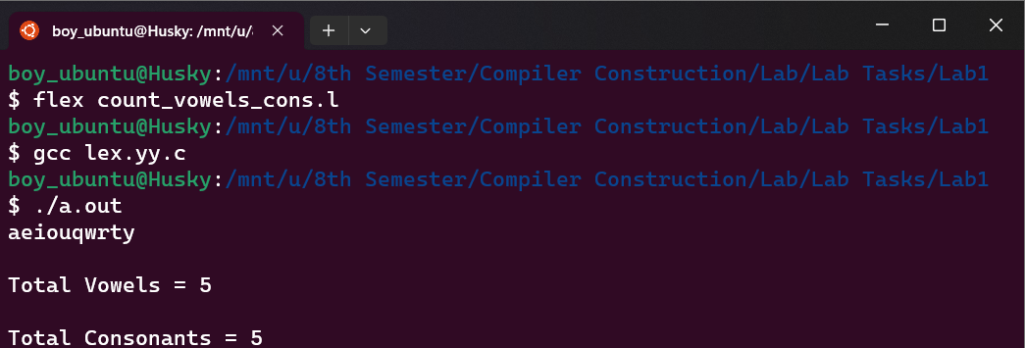

**Question 5  
  
Count words with size less than 10 and greater than 5**

%{

int count = 0;

%}

%%

[a-zA-Z]{6,9} {count++;}

\n {printf("\nwords with less than 10 and greater than 5 words are= %d\n",count);

count=0;}

%%

.

int yywrap(){

return 1;

}

int main(){

yylex();

return 0;

}

**Output  
  
